C Notes

**Contents**

Pointers 1

Define Data types 2

# Pointers

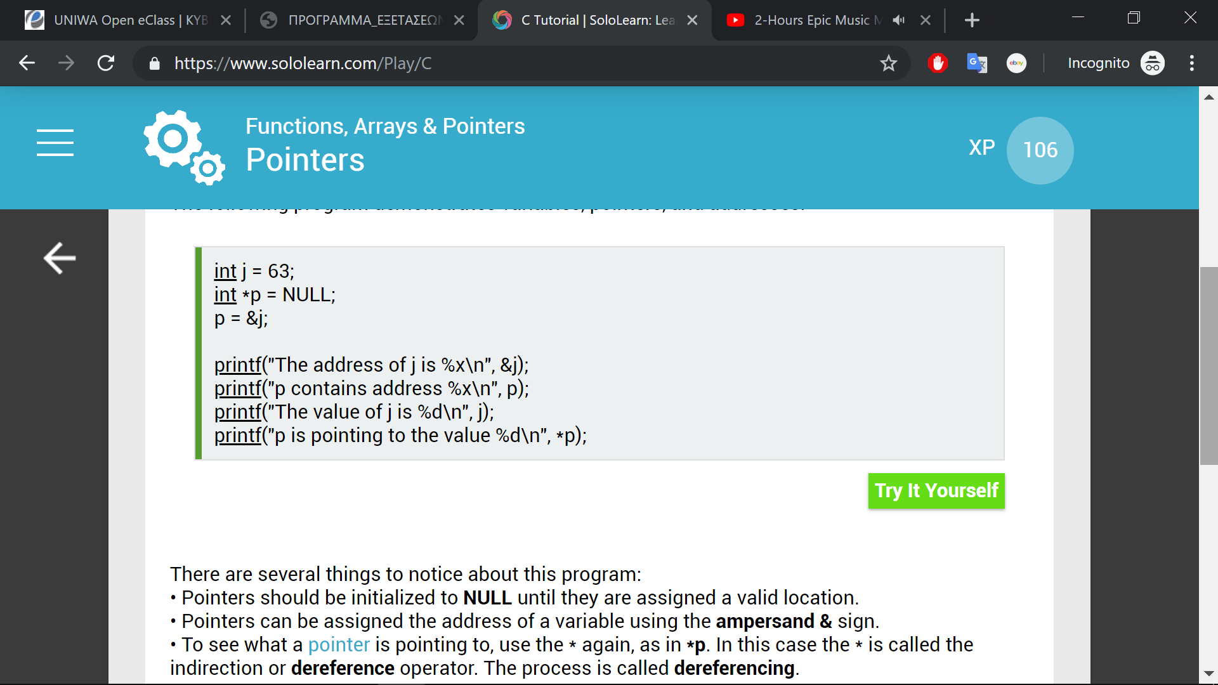

*p : the value of j.

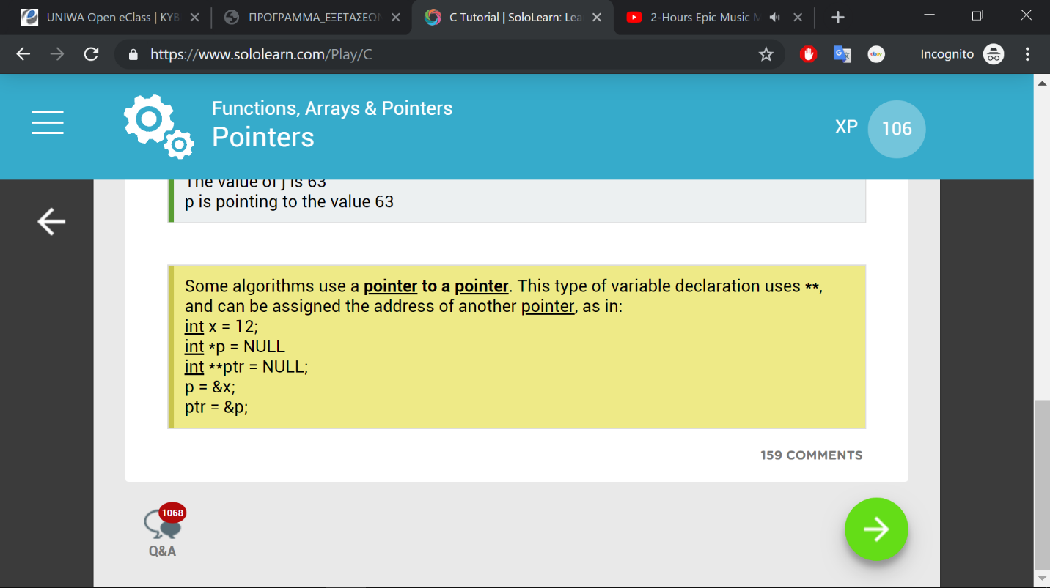

Note that parentheses are required for the ++ operator to increment the value being pointed to. The same is true when using the -- operator.

Example:

(*p)++;

# Define Data types

Define bool type variable

typedef int bool;

#define true 1

#define false 0;